Contents

Hypothesis testing 1

Alternate Hypothesis 2

P Value 2

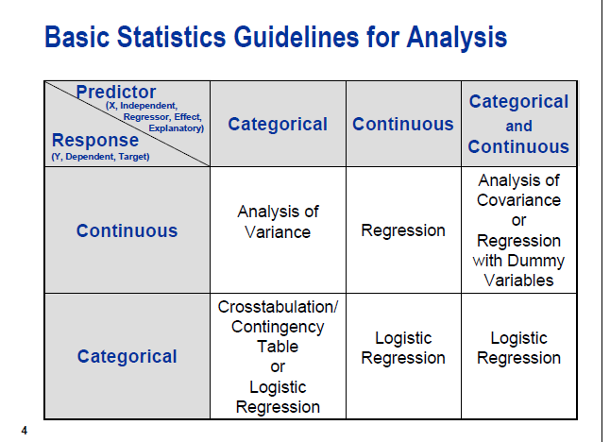

**1**

**Hypothesis testing**

* **Test about proportion**
* **Test about 1 mean**
* **Test of the equality of 2 means**
* **Test for variances**
* **2 Factor analysis of variances**

# Hypothesis testing

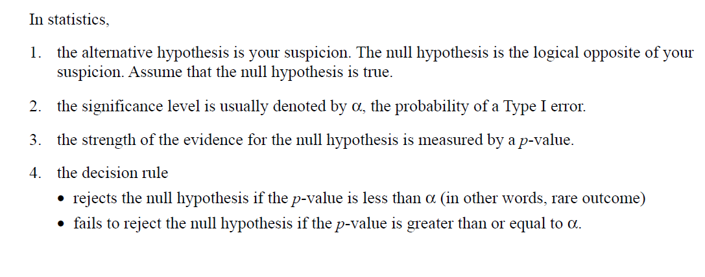

**Null hypothesis ,H0**

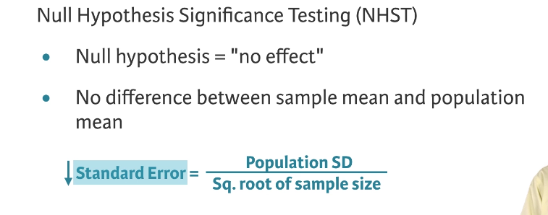

## Alternate Hypothesis

**Critical Value Method**

# P Value

P value is the probability of occurring an event by chance only

So if it is smaller than significant value than it means it is **unlikely** that this is just by chance that means our claim or alternative hypothesis can be true and we reject the null hypothesis.

For example –

Assuming null hypothesis is true , what is the probability of alternate hypothesis occurring by chance

Largest significance level we could carry out this test, and still fail to reject the null hypothesis

Simple words – Probability of obtaining an effect as extreme as the one in your sample data , assuming the truth of your null hypothesis

The p-value is the probability of finding any result under the test conditions for a given set of data presuming that the null hypothesis were true. The p-value has to be smaller than the significance level because that gives us an indication that the probability of that result happening is very low (in most cases, less than 5%) *by chance only*, and that is why it is most probably the real state of the world.

P-value = 0.064

The largest significance level at which we can carry out the test and fail to reject it, is: 6.4%

If we carry out test at 5%, we fail to reject it

If we carry out test at 10%, we reject it

Another interpretation: probability of observing a T value as large as 1.52, when null hypothesis is true

Small p-values are evidence against H0

Roughly

p-value

speaking, we interpret the p-value as follows: a small p-value indicates that

it is unlikely to observe such a substantial association between the predictor

and the response due to chance, in the absence of any real association

between the predictor and the response.

# Numericals

1. **Claim 1**: Students on average do 25 hours of part-time work – 20 points

Freshmen.jmp

H0 = Null hypothesis= 25 hours

Ha ≠ 25

Since in this claim difference in mean is hypothesized , we need to do the **2 Tailed test.**

**Claim 2: High School GPA is less than 3.3 – 20 points**

**Freshmen.jmp**

H0 = Null hypothesis <= 3.3

Ha >3.3

In this case since H0 is a hypothesized upper bound , we will do the **Upper Tailed T test**.

1. **Claim 5a**: Cholesterol level for fresh serum is the same as frozen serum 10 points

**Claim 5b**: Cholesterol level for fresh plasma is the same as frozen plasma 10 points

Total cholesterol.jmp

H0 null hypothesis -> [μ](https://en.wiktionary.org/wiki/%CE%BC)(Cholesterol level for fresh serum) =[μ](https://en.wiktionary.org/wiki/%CE%BC)(Cholesterol level for frozen serum)

Ha Alternate hypothesis -> [μ](https://en.wiktionary.org/wiki/%CE%BC) (Cholesterol level for fresh serum) ≠ [μ](https://en.wiktionary.org/wiki/%CE%BC)(Cholesterol level for frozen serum)

Since in this claim difference in mean is hypothesized , we need to do the **2 Tailed Test .**